Day 5 - June 28, 2018 -Thursday
“A loss of sight - never a loss of vision!”

Camp Abilities News
  - “Believe you can achieve!”

Last night’s dance party was a huge success. Most athletes participated and learned a new dance. The day’s activities went on as planned - the rain did not affect much of anything. Today - weather forecasters say skies will clear by this afternoon.
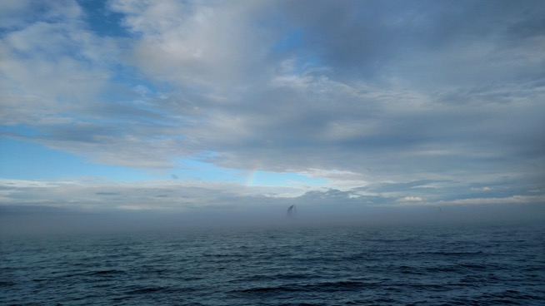

Photo taken by Marc Lieberman, Sailing Specialist, Lake Ontario, 06/27/2018

Care to Share - right after breakfast

Dan: danced at dance party.
Mackenzie: practiced for talent show, can’t wait for the talent show.
Faith: dance party emcee, hope to break 9 miles on tandem bike.
Elora: in gymnastics vaulted, worked on cartwheel
Braiden: congrats to Lt. Dan. Became Lt. himself and arm-wrestled Dan.
Chris: made it to semifinals of Showdown.
Anneka: did a cartwheel for the first time.
Luke: had fun at dance party with Deanna, Meghan and Tori.
Austin: helped DJ the dance party.
* ^ * ^ * ^ * ^ * ^ * ^ * ^ * ^ * ^ * ^ * ^ * ^ * ^ * ^ * ^
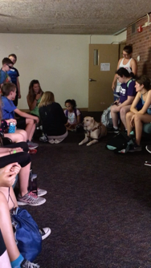

Happy Birthday Valeria!

Families and Friends- be sure to check back each day to see what your athlete has been doing. Also, many more photos on Camp Abilities Facebook page.

Arts & Crafts

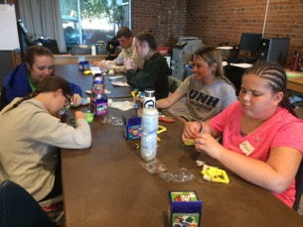
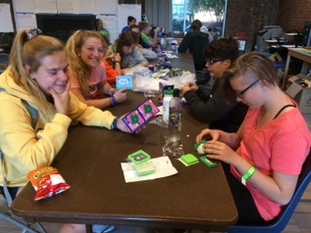

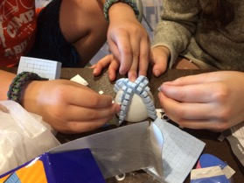
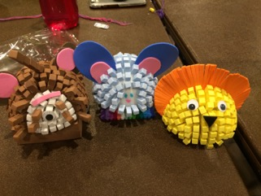

Care to Share - After Supper

Jaylyn: swam underwater, blew nose under water.
Andrew: forward roll on bar in gymnastics.
Kat: ran the 50 meter in 8:28.
Mina: swam in the deep end of the pool - 12’.
John: ran the 800 meter in 2:58. Also, ran in the National Track Meet.
Donovan: 38 laps on paddle board, fell in water once. Also, thank you to Avon Lioness for tonight’s supper.
Faith: on tandem bike completed 28 laps = 7 miles. In gymnastics, forward roll on the bar.
Meghan: completed a flip turn in swimming.
Emily: was able to dive into the pool during swimming.
Adam: completed a forward roll on the bar during gymnastics.
Elora: in Track & Field achieved a 6’ long jump.
Leah: tree pose on stand-up paddle board for 7 seconds. In gymnastics, forward flip on bar, back hip circle, parallel bars.
Dan: Tandem bike lap with Mark, Brockport PD, gymnastics forward roll and recruited for the police department.
Jacyn: impersonation
Peter - Specialist, 20 years at Camp Abilities. Swims in special Olympics in Washington State.

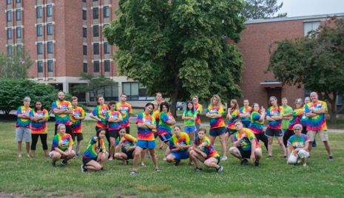
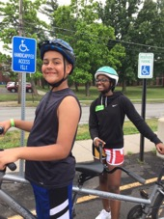

Getting ready to ride out - 2-mile bike ride.
Specialists! Instructors and leaders in all sports activities: Track & Field, Tandem Biking, Stand-up Paddle Board, Goalball, Gymnastics and Fitness, Beep Baseball, Swimming, Arts & Crafts.

