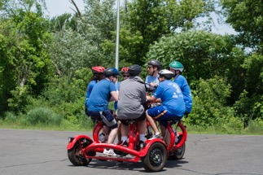
Day 3 - Tuesday - June 26

Camp Abilities News
  - “Believe You Can Achieve!”
Another great day of accomplishments for our Athletes. Weather was perfect for all outdoor events. Everyone participated!

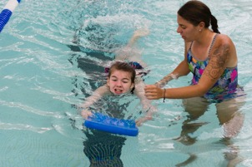
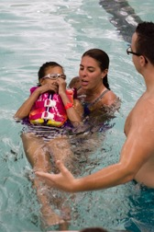
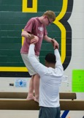
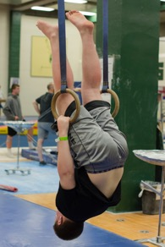

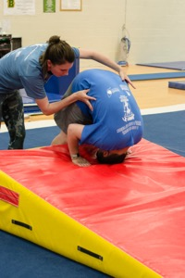
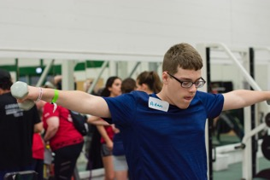

Physical fitness and gymnastics are an integral part of Camp Abilities. The Camp was predicated on blind and visually impaired young people being included in all sports.

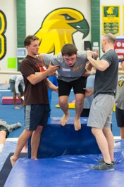

“Care To Share”

MacKenzie: Gymnastics, cartwheel.
Chantel: Gymnastics, back walkover. Paddle Board, stood up.
Elara: Paddle Board, 6 laps, didn’t fall.
Andrew: Beat brother’s score in Showdown.
Braiden: Won a Showdown game, sang with TK.
Jaylyn: Tree pose on Paddle board.
Ronan: Gymnastics, Skin the cat, puffed harder than ever before.
Henry & Chris each caught a fish!
Donovan: 20 laps on the Tandem Bike, tried the balance beam in gymnastics.
Bryce: ran 1 mile in 9 minutes, 30 seconds.
Chantal: 6 hits in beep ball, goal ball “rocked it.”
Ronan: ran 1 mile in 11 minutes, 9 seconds.
Mina: ran 1 mile in 11 minutes.
Chris: 43 laps on the tandem bike.
Dan: single ride first time. Paddle board, no wipe outs.
Jaylyn: ran 4 laps under 12 minutes.
Kat: small goal was to run without walking. Large goal was to lower 1 mile run time from last year. Done! 12;54 last year. 12:13 today. Did not slow down.
Braiden: ran 1 mile in 12 minutes.
Andrew: Gymnastics over the pommel horse for the first time.
Faith: went sailing for the first time and even helped steer the boat. Gymnastics did a cartwheel.
Sean: Swimming, did 10 flip turns.
Elora: ran 1 mile in 11:18. Beat last year’s record of 11:30.
Anneka: Ran 1 mile in 11:54.
Alex: Paddle board for the first time. Tandem bike 7 laps. Went sailing for the first time.
Kiana: ran 1 mile in 13:37
Nate: completed 6 laps in swimming.
Andrew: 11 laps on tandem bike. Gymnastics, 1 flip over the bar.
Adam: 11 laps on the tandem bike
David: earned 3 tokens in 3 events!
Angelina: completed 25 laps on the tandem bike, In gymnastics did a flip over on the bar.
Bella: 10 laps on paddle board, did not fall off. Gymnastics back walkover and cartwheel.
Diana: in goal ball threw a curve ball and in swimming completed a flip turn.
Leah: 4 flip overs in gymnastics, paddle board 7 laps.
Jayson: “hover bike for everyone!”

Families and Friends of Camp Abilities - be sure to check out our Facebook page and Shutterfly to see many more photos of the day’s events featuring your athletes doing amazing feats!
