Five Thousand Miles. One Month. Four Million Children Who Are Visually Impaired.

Vinicious (Vinny) tosses a ball and listens for it to land. He can't see it. He can't chase it. He can only hear it. He tosses his ball over and over again, listening to the splat of rubber on the ground. Vinny is blind, and yet he loves to play. Camp Abilities allows him to do more than listen. Camp Abilities is an educational sports camp for children and teens who are blind, visually impaired or deafblind. Camp Abilities teaches children like Vinny and Faustina and Emmanuel that being visually impaired is not a stop sign but simply a trait that must be considered.

Dr. Lauren Lieberman has spent the last twenty-five years teaching children who are visually impaired, their parents, teachers, and coaches how to overcome barriers to athletic achievement. She takes beep balls, tethers, guidewires, and auditory soccer balls into schools and communities. She provides encouragement and confidence and enthusiasm. She takes a passionate belief that all children have the ability, and the right, to participate, to achieve, to advocate. To play. To score. To win.

Camp Abilities began in 1996 with one camp in Brockport, New York. It now impacts children who are visually impaired in more than twenty states and seven countries. Dr. Lieberman will not be satisfied until Camp Abilities reaches across the globe. Being honored with the US State Department's Fulbright Global Scholar Award and supported by the Lion's Club, Dr. Lieberman was privileged to share and expand Camp Abilities in Ghana, Ireland, and Brazil. In August 2019, she began a fifteen thousand mile, 90-day journey across three continents.

In Ghana, she faced delayed funding, fire ants, and food poisoning. She faced cultural and language barriers. She was often tired and sick and frustrated. But at each stage of her journey, she met educators and professionals who wanted the best for their students. She met children who, for the first time, ran a race or kicked a ball or floated in water. She listened as cheers and laughter filled the air. She watched children who had been marginalized take their rightful place in the fields, tracks, and pools.

Her journey started with 100% humidity in the west of Africa.

Ghana is five thousand miles from Dr. Lieberman's home in western New York. A world away and a world of differences. Situated on the Gulf of Guinea, Accra, Ghana, is located on the west coast of Africa. Among its 28 million citizens, over four million are children who are blind, visually impaired or deafblind. Unlike children who are visually impaired in the US, these children are not included in local schools and sports programs. They attend special schools far away from their homes and their communities.

Dr. Lieberman was dismayed and discouraged to learn that while Ghana had several schools for children with intellectual disabilities and the Deaf, there were only three schools dedicated to the educational and social needs of children who are blind. None of the three schools were near Accra and the University of Ghana.

Meet "tall" Emmanuel, a 16-year old young man who never attended school because it wasn't available to him. When he arrived at the University of Ghana for camp, he had never run. At Camp Abilities, he learned to run with a human guide and then with a guidewire. Soon his confidence grew, and he discovered the freedom to run across the safe grass of a soccer field independently. At the end of the three-day camp, he was not only running, but he was also recording his time, intending to get faster at home.

Dr. Lieberman's goal was to teach the Ghanaians how to organize and run Camp Abilities. But, unlike the US, Ghana does not have a camp culture. "Going to camp" was an unknown concept. She had expected to arrive in Ghana ready to introduce sports recreation for children who are blind. Instead, she discovered nothing planned or organized. No facilities. No coaches. No meals. As she puts it, "We didn't even know where the kids were."

Believe You Can Achieve is the Camp Abilities motto. Dr. Lieberman believed in Camp Abilities for Ghana. She would achieve Camp Abilities for Ghana.

Just as she teaches students who are visually impaired to do, she adapted. She met Otemfour, a 30-year old gentleman who provided physical education to the local schools. She, Otemfour and her colleague from the University of Ghana, Dr. Reggie O'Cansey, drove high into the mountains to the School for the Blind in Akropong and to the School for the Deaf in Mampong. She had hoped – and expected – excitement about a camp for children who are visually impaired. She learned, however, that the children had no way to get to Accra. Camp, it seemed, would not be possible for these kids.

Just as she teaches students not to give up, she immediately suggested a second camp for September in Mampong. Dr. Lieberman now had two camps to run and still no infrastructure. Undaunted, she moved forward and soon dominoes began to fall. She was introduced to Angela, the Perkins School of the Blind representative to Ghana. Angela initiated contact with the appropriate staff at the US Embassy who set up a meeting with the person in charge of education for children who are visually impaired and deaf. The last domino fell when she was introduced to the newly appointed director of education. Camp Abilities was one step closer to becoming a reality. Dr. Lieberman, and this additional support team, combined their resources and talents and went to work.

Invitations were sent, staff was organized, calls were made, equipment and facilities were arranged, and t-shirts were ordered. After many long days of hard work, perspiration and persistence, students were finally registered. Paralympic coaches were recruited. It had been an uphill battle, but Camp Abilities opened on August 26 with temperatures in the nineties and 100% humidity.

Before the speeches could begin, an unexpected bus from Burkina Faso arrived. Burkina Faso is a small country north of Ghana with twenty-one million people who primarily speak French. They had driven 24-hours to present Reggie a trophy for his ongoing work in Ghana. With the help of interpreters, Dr. Lieberman talked to the Burkina Faso representatives. They are excited about the prospect of starting a camp in their country. Dr. Lieberman is eager to lend her support, her expertise, and her enthusiasm to the children of Burkina Faso.

Music, speeches, and a goalball tournament opened the day and energized the campers, the coaches, and the facilitators. It was time to show the Ghanaians that everyone can participate!

Fifteen students and ten coaches were ready to run and swim and throw a shot put. Five of the campers arrived from Cape Coast. They had boarded a bus at 3:30 that morning for the long ride to Accra. One determined young lady, Faustina, had traveled for four hours before she boarded the Cape Coast bus.

Meet "short" Emmanuel, a young man who dreams of playing on the Ghana national goalball team. At Camp Abilities, he learned how to stretch, to build endurance and strength without the aid of any equipment. He can go home where there are no running tracks or flat sidewalks and still take care of his body. He can achieve his dreams because Camp Abilities gave him the tools and the confidence.

In Ghana, as with many African nations, swimming is not an everyday activity. But with Dr. Lieberman's passion for allowing children who are visually impaired the opportunity to experience any and every physical activity possible, she stepped into the pool. The kids were equal parts scared and excited about swimming. She allowed the students to feel her arms and legs during a swim stroke. The children worked with a partner and learned to float. Imagine feeling yourself sinking and having no ability to see the edge of the pool or know the depth of the water. The kids started with two seconds and built from there. She taught the kids to communicate, to trust, to be brave.

Meet six-year-old Arturo. He'd never played any sport. He attended the two-day camp at Mampong. At Camp Abilities he discovered the goalball and the guidewire. He played on his first team and even scored his first goal and learned what it meant to play and jump and scream in triumph. He discovered a world previously unavailable to him.

Camp Abilities held a closing ceremony, but Camp Abilities never actually closes. It is a sports camp. But it is so much more. Camp Abilities is a camp of accomplishment and confidence. For 25 years and across the globe, Camp Abilities has changed the lives of students and parents, communities and cultures. Camp Abilities is Dr. Lauren Lieberman's Passion Project. With the support of the US State Department and its Fulbright Global Scholarship, her passion has reached Ghana and will soon reach Burkina Faso and South Africa.

Vinny tosses a ball, listens to the beep, and smiles when the ball lands in his palm. That is Dr. Lieberman's passion and the goal of Camp Abilities.

Next stop: Ireland

A rewarding side note: While visiting Ghana, Dr. Lieberman learned that the Ghana educational system is implementing a significant curriculum change. Soon, children who are visually impaired, deaf and intellectually challenged will no longer be separated from their families and their peers. Ghana is beginning to place its students with disabilities in the local schools. Ghana is one step closer to inclusion!

For more information about Camp Abilities, please refer to campabilities.org.
~June A Converse, March 2020

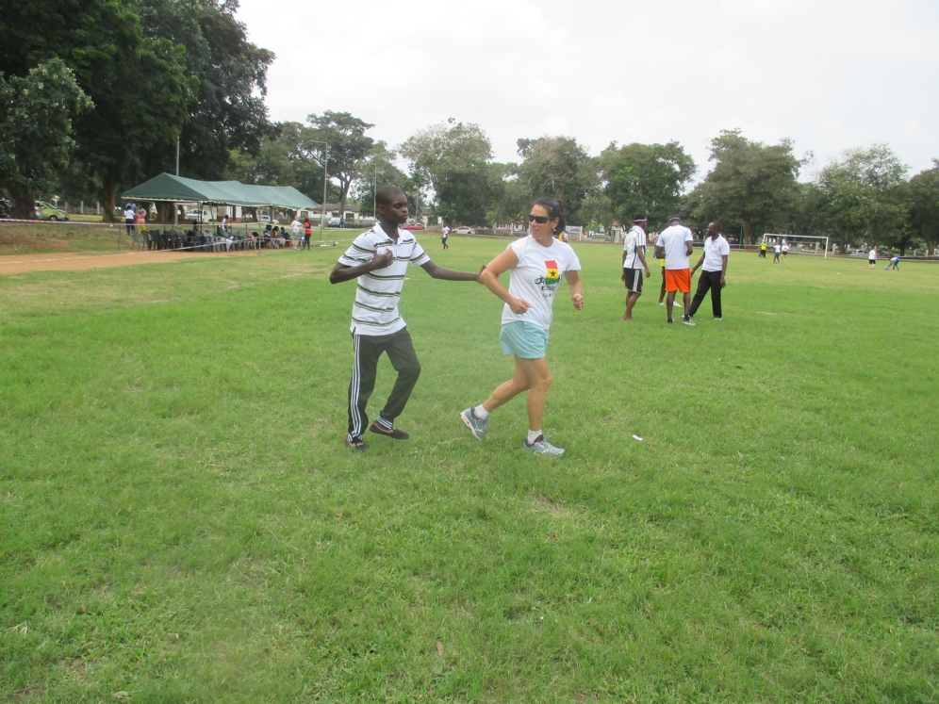

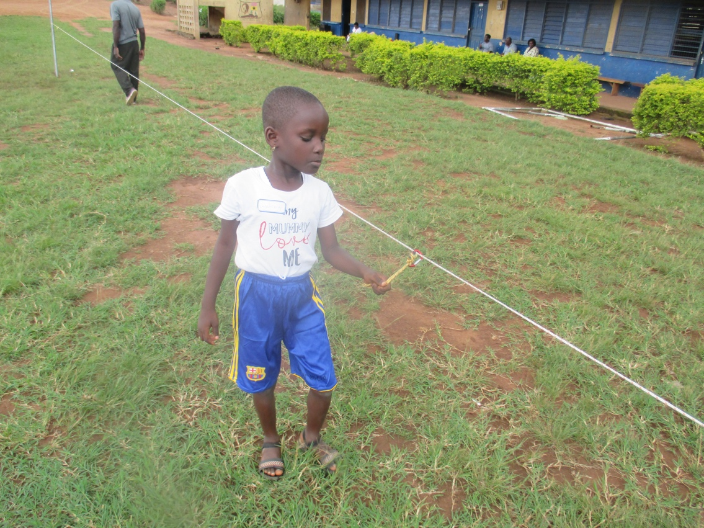
Photo Descriptions:
Photo above: Dr. Lieberman running with a student using sighted guide in a large field.
Photo below: Young student runs using a guide wire.

