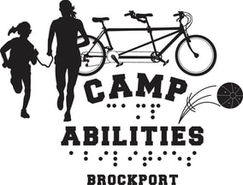
Camp Abilities 5K
Walk, Run, Roll!

A Family Friendly Walk, Run, or Roll 5K Course and 100m Kids Race
Saturday, October 27th, 2018.

Camp Abilities is an educational sports camp for children with visual impairments, blindness, or deaf-blindness held on the SUNY-Brockport Campus each year.

8:00am: Registration Begins on the SUNY-Brockport Track
8:30am: 100m Kids Run
9:00am: 5K Starts
5K cost: College-aged and younger $10, Preregistration for adults is $15, Same day registration is $20 ALL including a water bottle
100m Kids Race: Free!

Come out to exercise and support a great program!
Donations are also welcome at http://www.campabilities.org
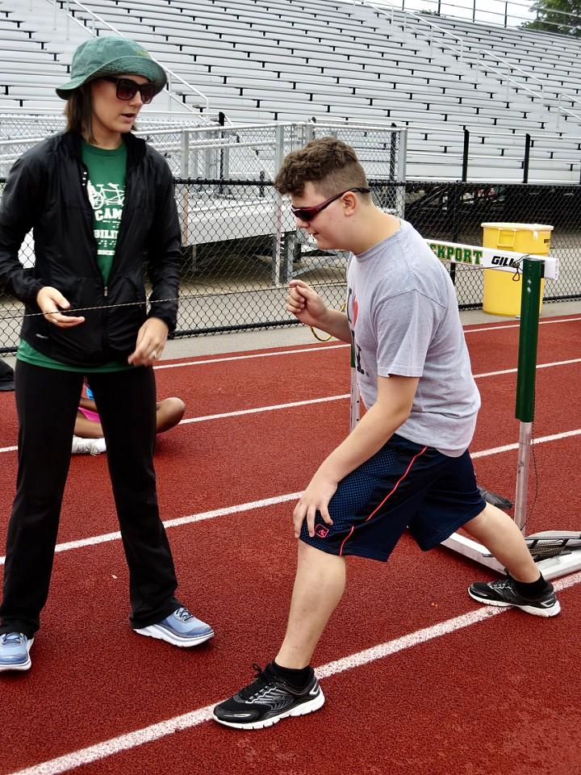
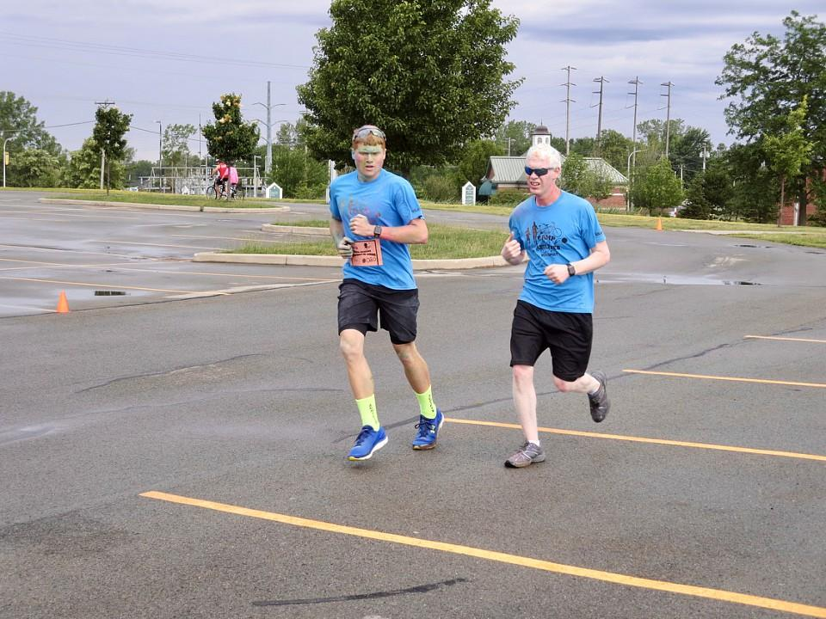
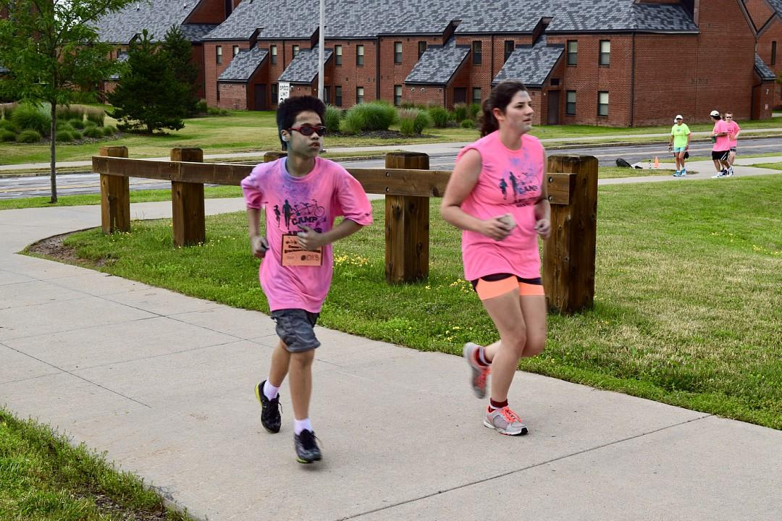
For more information please contact: Kristi Lane at: klane5@brockport.edu or 585-456-4701

First and Last Name: ______________________________________________________
Email: ______________________________________________________________________
Address: ___________________________________________________________________
Phone Number: ____________________________________________________________
Select one of the following for divisions: Male_____ Female ______
Select one of the following age categories:
11-18 _______ 19-25________ 26-45_________ 46-55_________ 55+___________
Select which applies to you:
5K walk__________ 5K Run___________ 5K Roll________________
Emergency Contact: Name: ____________________ Phone: __________________
Race selections please circle all that apply:
- 5K Walk/Run/Roll
- 100m Kids Race
Payment methods please circle one:
- Cash
- Check made out to Research Foundation
- Online Payment at campabilities.org under “Donate” – please write in 5K registration if using this method.
Signature below indicates your agreement to indemnify and hold harmless and hereby releases, waivse, discharges and covenants not to sue, The Research Foundation for SUNY, The State University of New York, The State of New York, The Village of Brockport, and Camp Abilities Brockport, as well as any members, officers, agents, servants, and employees of the same from any and all liability, claims, demands, actions, losses, expenses (including court costs or attorneys fees), and causes of action whatsoever arising out of or related to any loss, damage, or injury, including death, that may be sustained by me or my child or legal ward, or any property belonging to me or my child or legal ward, while participating in the 5 K event.

I am fully award of the potential risks and hazards with participation, including but not limited to travel, medical and or accident risks and voluntarily assume those risks binding myself, members of my family, spouse and heirs to this Waiver of Liability and Hold Harmless. It is my responsibility to sustain or acquire and maintain adequate insurance for participation.

_____________________________________________ _______________________
Signature (Parent or Guardian if under 18) Date

Please return Registration and Payment to:
Attn. Kristi Lane
Camp Abilities
350 New Campus Drive
Tuttle North 343
Brockport, NY 14420
Or Email Registration to: klane5@brockport.edu

