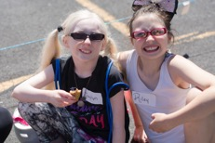
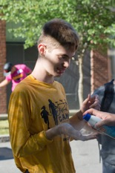
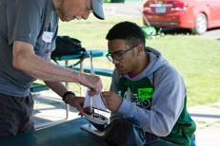

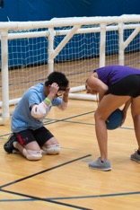
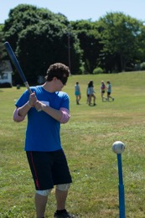
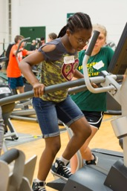
Day 2 - June 25 - Monday

Camp Abilities News
  - “Believe You Can Achieve”

Big day today! Athletes participated in Goal Ball, Swimming, Gymnastics, Tandem Bike Riding, Paddle Boarding, Track, Fitness, and Beep Ball. Many exceeded their personal best from last year. New athletes set goals and met them in various sports.

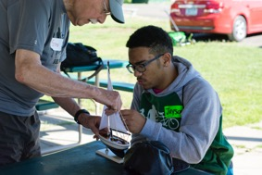 |  | Sailing!  First, we learn - then we sail!
 |  | 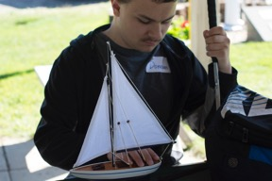
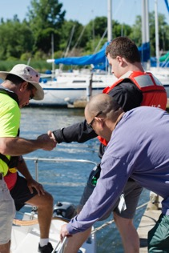

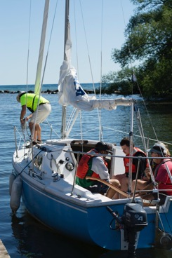
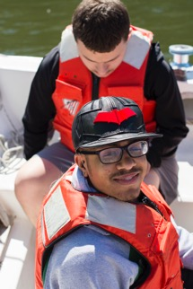
Perfect day for sailing! Perfect day for learning to sail. Lots of hands-on experience for the Athletes.

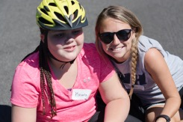
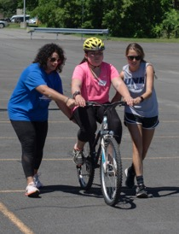
Tandem Biking
Way to go Keara! With Coach Tess and Gina.

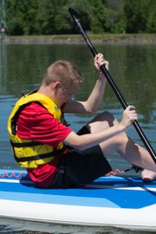
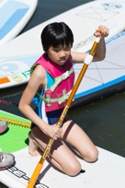
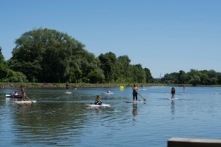
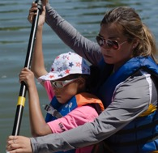
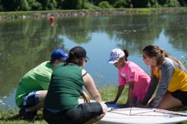
Paddle Boarding

Swimming
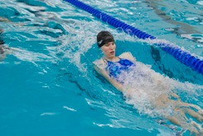
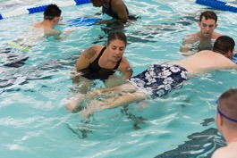
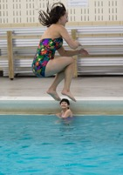
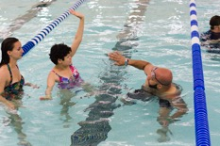
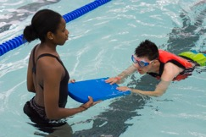

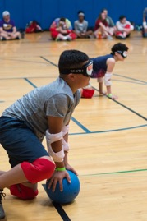
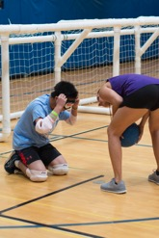
Goal Ball

Care to Share

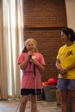
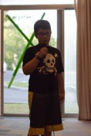
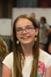
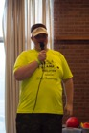

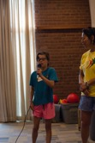
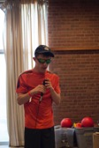
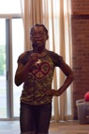
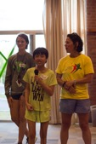
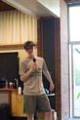
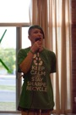
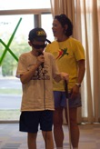
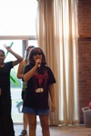
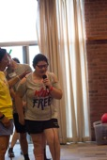
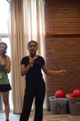

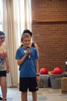
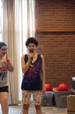
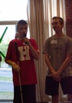
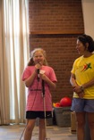
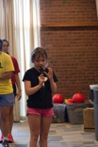

Meghan: 25 laps on tandem bike, exceeded goal in gymnastics.
Bryce: did a flip in gymnastics
Henry: throw discus 81 feet
Jaylyn: 30 laps tandem bike
Anneka: 30 laps = 6 miles tandem bike, paddle board, high balance beam
Quinton: paddle board
Ronan: Rode a bike for the first time
Faith: Track & Field - 14.15 sec. running
Dan: Track & Field - 12:55 sec. running and swimming
Kat: paddle board 7 laps, 30 laps = 6 miles tandem bike
Mina: cartwheel in gymnastics for the first time
Laura: front and back flip on bar and cartwheel
Kiana: 10 laps tandem, hung on bar in gymnastics, paddle board 1 lap
Sean: 2 miles on a bike
Leah: 1 mile in 9 minutes 29 seconds
Krista: swam for the first time
Braiden: 37 laps on tandem bike, stood up on paddle board and tree pose, helped carry buoy
Abbey: gymnastics wishes to compete in rings tournament
Diana: paddle board 9 laps, gymnastics back bend and split, multiple pivot turns
Sky: ran a 1 mile in just over 6 minutes

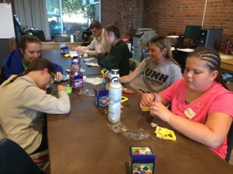

Arts & Crafts
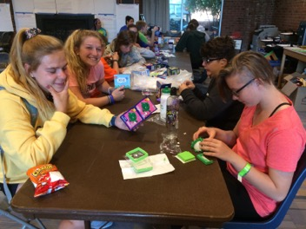

Terry Kelly - Party Down
